Year 1 Recommended books to share with an adult
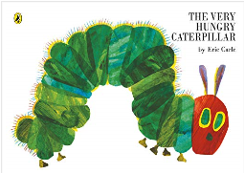
The Very Hungry Caterpillar – Eric Carle
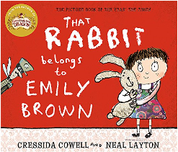

That Rabbit Belongs to Emily Brown – Cressida Cowell & Neal Layton
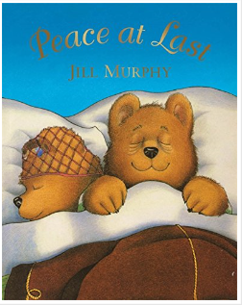
Peace at Last – Jill Murphy
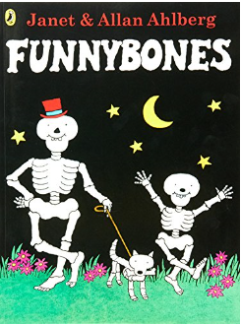

Funnybones – Janet & Allan Ahlberg

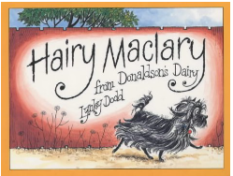
Hairy Maclary from Donaldson’s Dairy – Lynley Dodd
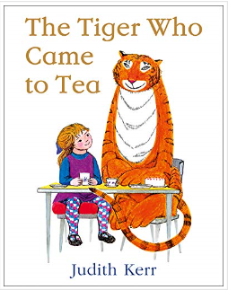
The Tiger Who Came to Tea -
Judith Kerr

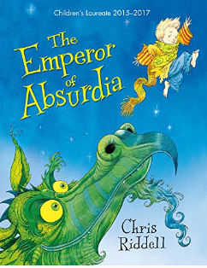

The Emperor of Absurdia – Chris Riddell

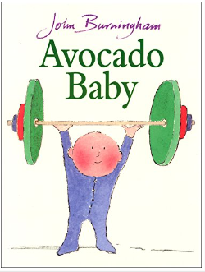
Avocado Baby
- JohnBurningham

More confident readers could try:
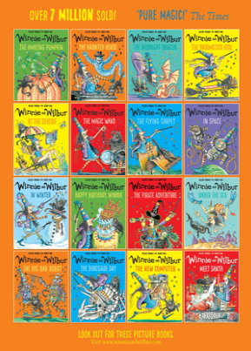
Large variety of books about the character Winnie the Witch – Valerie Thomas

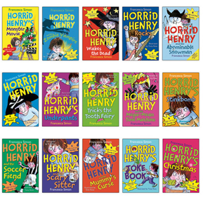

Horrid Henry collection – Francesca Simon

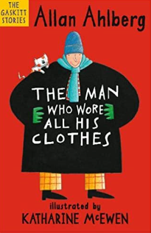

The Man Who Wore all his Clothes (The Gaskitt stories) - Allan Ahlberg

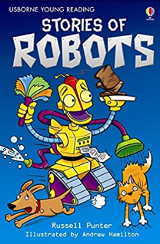
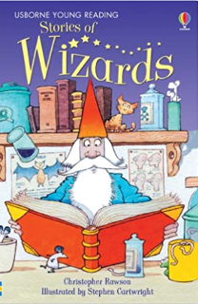
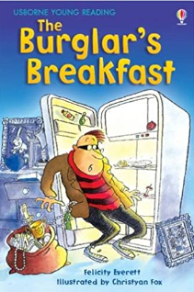
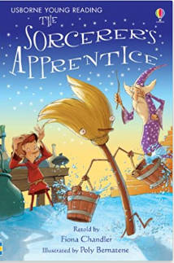
Usborne Young Readers Collections – various authors

